**Adding a Water System**

Using menu on the left expand ‘Water Systems’, then choose Water System Components.

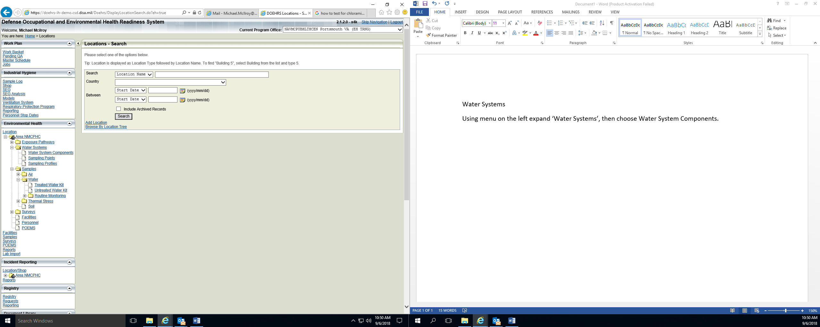

Using the + icon or ‘Other Actions’ pick list you will add a Water System Component. You will need to know the Water System name, type of source, source and disinfection technique. Input the required information and select save.

